1. Goals:

For this project, my original goal was to gather 100 Facebook photos and posts, their information, and put it into a SQL database. Once I gathered this information I planned on finding what days I posted the posts and photos and how many likes each photo/ post received. I also planned to find out which days I posted photos/posts the most frequently. I also planned on splitting the data up by time.

I also planned on gathering data from the Apple Music API and the Instagram API as well as using a word cloud.

1. Which goals I achieved:

For the Facebook API, I achieved all of my goals, except, I did not include posts and could not figure out how to do the time. I realized that my posts and the photos on Facebook were the same information because I only post photos on Facebook. I figured this was redundant to include. The time was too difficult for me to include.

I did not end up gathering data from neither the Apple Music API , the Instagram API, nor using a word cloud because it was not necessary for my project. I did not need as many points as I thought I originally did.

1. What problems I faced:

I had a difficult time splitting the timestamp that was provided in my data. I also faced problems gathering the data into an organized list that I would be able to easily access when inputting it into SQL.

1. Social Media Report:

This is the output from terminal for my code after making a frequency counter for posts and days:



This is the code for my frequency counter:

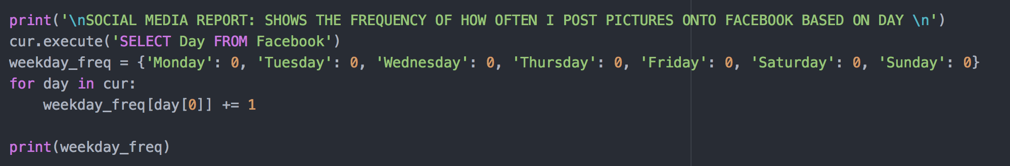

1. Instructions for running code:
2. Documentation DESCRIBE THE FUNCTIONS HERE:
3. Documentation of Resources:

|  |  |  |  |
| --- | --- | --- | --- |
| **Date** | **Issue Description** | **Location of Resource** | **Result**  **(did it solve the issue?** |
|  | Directions for API Setup | <http://facebook-sdk.readthedocs.io/en/latest/api.html> | Helped to provide how to request data |
|  | Pip Install Facebook-sdk tools | <http://facebook-sdk.readthedocs.io/en/latest/install.html> | Yes, this told me what to type into terminal to use a version of the Facebook SDK |
|  | What the data looked like | <https://developers.facebook.com/docs/graph-api/overview/> | Provided a basic overview of the Facebook API and what capabilities it contained. Also provided a basic overview. |
|  | Obtaining Access Token | <https://developers.facebook.com/tools/explorer/> | Yes, this website provided the access token for me |
|  | Access Token expired | <https://developers.facebook.com/docs/facebook-login/access-tokens/expiration-and-extension> | Yes, apparently you need a new access token for Facebook every once and a while. There is no way to really solve it, without getting new access tokens, however, my data is cached so I avoided the problem. |
|  | Gathering and Sifting through Data | <http://minimaxir.com/2015/07/facebook-scraper/> | This did not help in solving my issue, but helped me think about my problem in a different way. |
|  | Datetime Problems | <https://stackoverflow.com/questions/3682748/converting-unix-timestamp-string-to-readable-date-in-python> | Helped give me ideas for how to work with the Datetime function |
|  | Datetime Problems | <https://stackoverflow.com/questions/27432540/how-to-convert-api-timestamp-into-python-datetime-object> | Helped give me ideas for how to work with the Datetime function |
|  | Datetime Problems | <https://docs.python.org/2/library/datetime.html> | This helped me to better understand how the Datetime function works |